

Foundations of Programming

Assignment No.: 20
PROBLEM STATEMENT: Write a C function to swap two numbers with and without using pointers.

OBJECTIVE:

- To understand the concept of function calls in the C programming language.
- To learn the difference between call by value and call by reference.
- To demonstrate swapping of two numbers with and without pointers.

THEORY:
In the C programming language, swapping two numbers can be performed in two ways: without pointers (call by value) and with pointers (call by reference).

When swapping numbers without pointers, the values are passed to the function by value. This means that a copy of the variables is sent to the function, and any changes made inside the function do not affect the original variables.

When swapping numbers with pointers, the addresses of the variables are passed to the function. This allows the function to directly modify the original variables in memory. Pointers therefore enable efficient data manipulation and are widely used in C for handling memory and complex data structures.
PLATFORM: Linux
ALGORITHM:

Step 1: Start
Step 2: Input two integers a and b
Step 3: SWAP WITHOUT POINTERS (Call by Value):
a. Pass a and b to function swapByValue(x, y)
b. Inside function: temp = x; x = y; y = temp
c. Note: changes do NOT reflect in main (copies are swapped)
Step 4: SWAP WITH POINTERS (Call by Reference):
a. Pass &a and &b to function swapByRef(px, py)
b. Inside function: temp = *px; *px = *py; *py = temp
c. Changes reflect in main (original values are swapped)
Step 5: Display both results
Step 6: Stop

FLOWCHART:
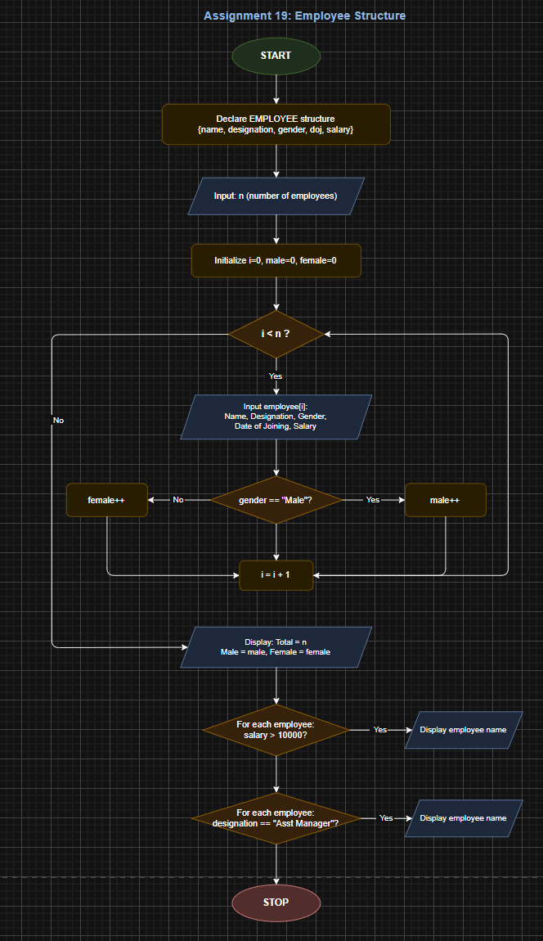
CODE:

#include <stdio.h>

// Call by Value - does NOT affect original variables
void swapByValue(int x, int y) {
int temp = x;
x = y;
y = temp;
printf("Inside swapByValue: x=%d, y=%d\n", x, y);
}

// Call by Reference - AFFECTS original variables
void swapByRef(int *px, int *py) {
int temp = *px;
*px = *py;
*py = temp;
}

int main() {
int a, b;
printf("Enter two numbers: ");
scanf("%d %d", &a, &b);

// Without pointers
printf("\n--- Swap WITHOUT Pointers ---\n");
swapByValue(a, b);
printf("After swapping without pointers: a=%d b=%d\n", a, b);

// With pointers
printf("\n--- Swap WITH Pointers ---\n");
swapByRef(&a, &b);
printf("After swapping with pointers: a=%d b=%d\n", a, b);

return 0;
}

INPUT: Two integer numbers.

OUTPUT: Displays swapped values using both call by value and call by reference methods.

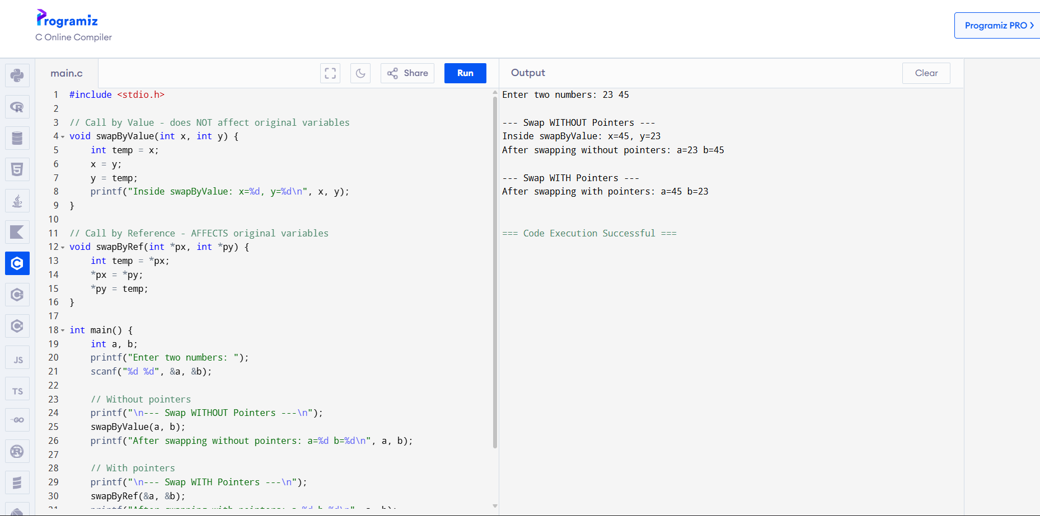

CONCLUSION: Thus, the C program successfully demonstrates the difference between swapping values using call by value and call by reference. Using pointers allows the function to modify the original variables directly.

